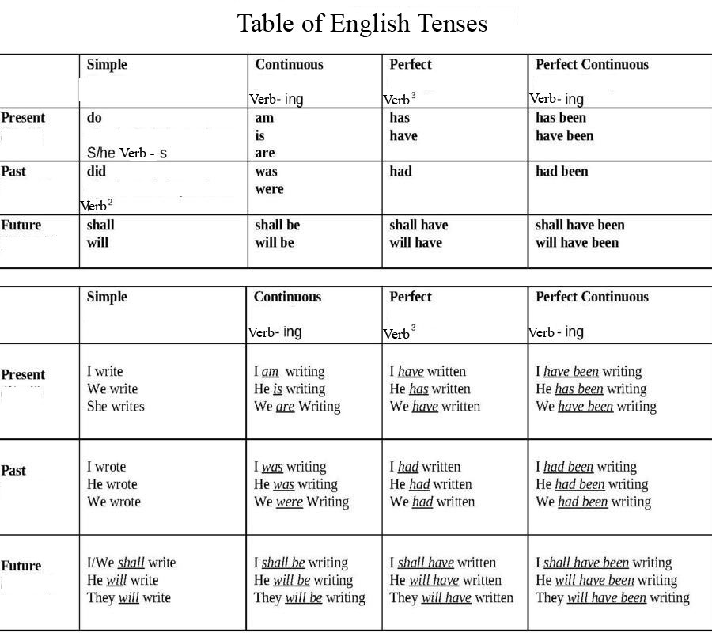

The Passive Voice is used in English when the person or thing that is receiving the action is more important than the person or thing that is performing the action.
The structure of a sentence in the passive is as follows:
Object + To Be + Past Participle
Look at the structure of the following sentences in the active and the passive voice to understand the difference in structure.
- I sent Christmas cards to all my friends. (Active)
- Christmas cards were sent to all my friends. (Passive)
- The earthquake destroyed the town last night. (Active)
- The town was destroyed last night. (Passive)
In these examples, you can see it is the action / result that is the most important factor in the passive sentences.

When to use the Passive Voice
1. It is used when the person/thing performing the action is unimportant or unknown.
e.g. Our car was stolen last night.
2. It is used when it is obvious who/what is performing the action.
e.g. Cameron was sacked last week.
3. It is used to describe factual information, especially when describing a process.
e.g. The lasagna is baked in an oven for 35 minutes at 250 degrees Celsius.
4. It is used in news reports and to give instructions.
e.g. Five people were arrested at a nightclub last night.
While it is possible to use this structure in a large variety of tenses in English, it is rare to use the passive in Future Continuous, Present Perfect Continuous, Past Perfect Continuous or Future Perfect Continuous tenses.

Below are examples of the passive in a range of verb tenses.
 | To Be | Past Participle | Tense
The butter | is | kept here. | Present Simple
The window | was | broken. | Past Simple
The work | will be | done soon. | Future Simple
The bridge | is being | repaired. | Present Continuous
The cheese | was being | eaten by mice. | Past Continuous
Our work | has been | finished. | Present Perfect
The car | hadn't been | used much. | Past Perfect
The house | will have been | built by then. | Future Perfect
The shelf | can't be | reached. | Modal Verb - Can
The task | must be | done now. | Modal Verb - Must
The lesson | may be | finished. | Modal Verb - May
The car | ought to be | repaired. | Modal Verb

